**Attentive Social Recommendation: Towards User And Item Diversities**

注意社交推荐：针对用户和项目多样性

Abstract

Social recommendation system is to predict unobserved useritem rating values by taking advantage of user-user social relation and user-item ratings. However, user/item diversities in social recommendations are not well utilized in the literature. Especially, inter-factor (social and rating factors) relations and distinct rating values need taking into more consideration. In this paper, we propose an attentive social recommendation system (ASR) to address this issue from two aspects. First, in ASR, Rec-conv graph network layers are proposed to extract the social factor, user-rating and item-rated factors and then automatically assign contribution weights to aggregate these factors into the user/item embedding vectors. Second, a disentangling strategy is applied for diverse rating values. Extensive experiments on benchmarks demonstrate the effectiveness and advantages of our ASR.

社交推荐系统将通过利用用户-用户社交关系和用户-项目评级来预测未观察到的用户项目评级值。 但是，社会推荐中的用户/项目多样性在文献中没有得到很好的利用。 特别是，因素间（社会因素和评级因素）的关系和不同的评级值需要更多地考虑。 在本文中，我们提出了一个注意力社交推荐系统（ASR）从两个方面解决这个问题。

首先，在ASR中，提出了Rec-conv图网络层来提取社会因素，用户评分和项目评分因素，然后自动分配贡献权重，以将这些因素聚合到用户/项目嵌入向量中。

其次，将分散策略（disentangling strategy）应用于不同的评级值。 在基准上进行的大量实验证明了我们的ASR的有效性和优势。

1 Introduction

Recommendation system aims to predict unobserved ratings based on users’ historical purchases. Users are also involved in social relations where they often acquire and propagate preferences. Social recommendation is to leverage the social factor in recommendation systems. It has been verified to be effective for alleviating the data sparsity and cold-start issue existing in traditional collaborative filtering-based recommendation methods (Wu et al. 2019c; Fan et al. 2019b).

推荐系统旨在根据用户的历史购买来预测未观察到商品的评分。 用户涉及社交关系，他们经常获得和传播偏好。 社交推荐是在推荐系统中利用社交因素。 它已被证明可有效缓解传统基于协作过滤的推荐方法中存在的数据稀疏和冷启动问题（Wu等人2019c; Fan等人2019b）。

In social recommendation, both user-user social relations and user-item rating data are often represented by graph structures. As shown in Figure 1, we structure the user-user relationship as a graph (blue part) and user-item ratings as a bipartite graph (red part) with edge weights representing rating values. Usually, rating values range from “1” to “5” with “1” as dislike and “5” as like most, for instance, in the two benchmark datasets in the experiments Ciao and Epinions. Taking advantage of graph neural network (GNN), e.g., graph convolutional network (GCN) (Kipf and Welling 2017) and graph attention network (GAT) (Veliˇckovi´c et al. 2018), recent works are proposed to extract features from the social graph and the rating graph (Wu et al. 2019c; Fan et al. 2019c,b). 在社交推荐中，用户-用户社交关系和用户项目评分数据通常都由图结构表示。 如图1所示，我们将用户-用户关系构造为图表（蓝色部分），将用户-项目等级构造为二分图（红色部分），边缘权重代表等级值。 通常，例如在Ciao和Epinions实验的两个基准数据集中，评级值的范围从“ 1”到“ 5”，其中不喜欢“ 1”，最喜欢“ 5”。 利用图神经网络（GNN），例如图卷积网络（GCN）（Kipf和Welling 2017）和图注意力网络（GAT）（Veliˇckovic等人，2018），提出了最近的工作来从 社交图和评级图（Wu等人2019c; Fan等人2019c，b）。

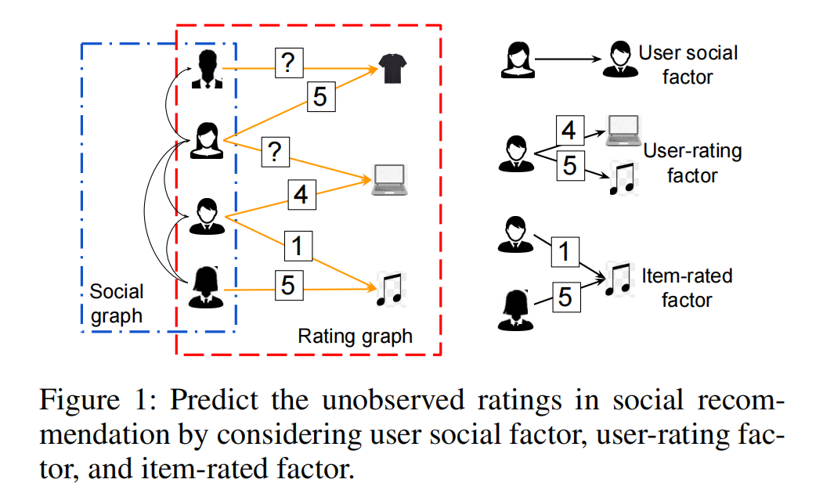

图1：通过考虑用户社交因素，用户评分因素和项目评分因素，预测社交推荐中未观察到项目评分。

As demonstrated in Figure 1, three factors are often taken into account in social recommendation. Social factor reflects that a user’s ratings may be influenced by the neighbors in the social graph. In the rating graph, we define user-rating factor as the effect on an individual user from all her/his ratings and item-rated factor as the impact on an item from all its ratings.

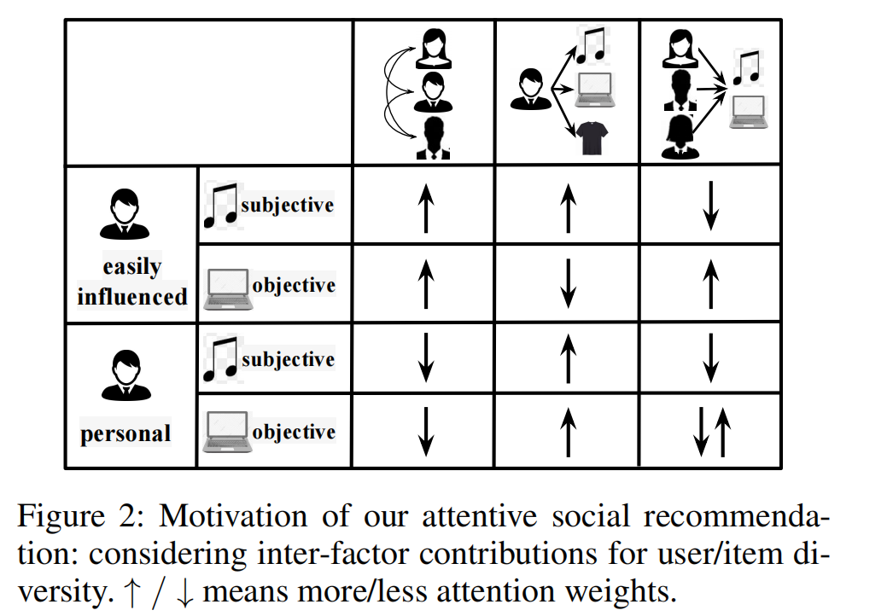

如图1所示，社会推荐中经常考虑三个因素。 社交因素反映出用户的评分可能会受到社交图中邻居的影响。 在评分图中，我们将用户评分因子定义为其所有评分对单个用户的影响，并将项目评分因子定义为其所有评分对项目的影响。

Despite the successes of feature extractors, diversity of users and items are not well investigated in the literature. There still are two main challenges. 尽管特征提取器取得了成功，但文献中对用户和物品的多样性研究并不充分。目前仍存在两个主要挑战。

First, existing works overlook the different contributions of the multiple factors when considering user/item diversities. Shown in Figure 2, we take four cases for illustration. For users, some users (the first two rows) are easily influenced by friends, i.e., more social factor should be paid attention; while some (the last two rows) have their unique preferences reflected by their own ratings (more user-rating factor and less social factor). Moreover, evaluating an item could be more subjective or objective. We should recommend a song (subjective items) based on users’ different tastes which means that more user-rating factor needs considering. But recommending a computer (objective items) would require more its overall ratings, i.e., more item-rated factor. User/item diversities in real scenarios are more complex than the four exemplars. Thus attentive inter-factor contributions should be emphasized. However, existing methods only separately extract some factor features. For example, GraphRec (Fan et al. 2019b) separately applies a GAT in either the social graph or the rating graph and then simply concatenates the extracted features for further rating prediction.

首先，在考虑用户/项目多样性时，现有作品忽略了多个因素的不同贡献。如图2所示，我们以四种情况为例。对于用户而言，某些用户（前两行）很容易受到朋友的影响，即应注意更多的社交因素；而某些（最后两行）的独特偏好会通过自己的评分（更多的用户评分因素和较少的社交因素）反映出来。此外，评估项目可能更主观或客观。我们应该根据用户的喜好推荐一首歌（主观项目），这意味着需要考虑更多的用户评价因素。但是，推荐一台计算机（目标项目）将需要更多的总体评级，即更多的项目评级因子。实际场景中的用户/项目多样性比四个示例更为复杂。因此，应该强调细心的因素间贡献。但是，现有方法仅单独提取一些因素特征。例如，GraphRec（Fan et al.2019b）在社交图或评级图中分别应用GAT，然后简单地串联提取的特征以进行进一步的评级预测。

Second, distinct rating values are not well exploited. “like” and “dislike” ratings may propagate in social and rating graphs in different patterns. But existing work, for example, DANSER (Wu et al. 2019c) does not distinguish the edge weights (i.e., rating values) in the rating graph and only utilizes rating values in the loss computation.

其次，没有很好地利用不同的评级值。 “喜欢”和“不喜欢”评级可能会以不同的方式在社交和评级图中传播。 但是现有的工作，例如DANSER（Wu et al.2019c）并未区分等级图中的边缘权重（即等级值），仅在损耗计算中利用了等级值。

To tackle the two challenges, in this paper, we propose an Attentive Social Recommendation (ASR) model to attentively fuse multiple factors for user/item diversities in social recommendation.

为了解决这两个挑战，在本文中，我们提出了一个关注社会推荐（ASR）模型，以专注于融合社交推荐中用户/项目多样性的多个因素。

For the first challenge, in ASR, a new graph neural network architecture, Rec-conv layer, is proposed. In each Recconv layer, GNNs are applied to extract the three aforementioned factors from the social graph and the rating graph. Attention mechanisms are utilized as well in each Rec-conv layer to automatically assign contribution weights on the three factors and to obtain factor-fused user/item embedding vectors.

对于第一个挑战，在ASR中，提出了一种新的图神经网络架构Rec-conv层。 在每个Recconv层中，应用GNN来从社交图和评级图中提取上述三个因素。 在每个Rec-conv层中也都使用了注意机制，以自动为这三个因素分配贡献权重，并获得与因素融合的用户/项目嵌入向量。

For the second challenge, ASR adopts a disentangling strategy to distinguish the propagation of “like” and “dislike” ratings. Specifically, for each rating value, we first induce a subgraph from the entire rating graph. Then we combine all the GNN-extracted user-rating and item-rated factors from each subgraph into the user/item embedding in each Rec-conv layer.

对于第二个挑战，ASR采用一种解缠策略，以区分“喜欢”和“不喜欢”评级的传播。 具体来说，对于每个评级值，我们首先从整个评级图中得出一个子图。 然后，我们将来自每个子图的所有GNN提取的用户评分和项目评分因素组合到嵌入在每个Rec-conv层中的用户/项目中。

Extensive experimental results on two real-world datasets verify the better effectiveness and efficiency of ASR than state-of-the-art methods. We also conduct ablation study to demonstrate the effectiveness of the inter-factor attention mechanism, the disentangling strategy and GNNs, and to examine the sensitivity of the stacked the Rec-conv layers to the over-smoothing issue (Li, Han, and Wu 2018).

在两个真实的数据集上的大量实验结果证明，与最新技术相比，ASR的有效性和效率更高。 我们还进行了消融研究，以证明因素间注意机制，解缠策略和GNN的有效性，并检查堆叠的Rec-conv层对过度平滑问题的敏感性（Li，Han和Wu 2018 ）。

Our major contributions are summarized as follows.

• Diversities of users and items are investigated. Inter-factor contributions and distinct rating propagation are vital to social recommendation.

•调查用户和物品的多样性。 因素间的贡献和独特的评分传播对社会推荐至关重要。

A novel attentive social recommendation (ASR) system with stacked Rec-conv layers is proposed to effectively fuse multiple factors for user/item representation learning.

提出了一种新颖的，具有堆叠式Rec-conv层的注意力社交推荐系统（ASR），以有效融合多种因素，实现用户/项目表示学习。

Extensive experiments on two benchmarks demonstrate the advantages of ASR both in effectiveness and effi- ciency.

**2 Related Work**

Classic recommendation system. Collaborating filtering based methods are widely used in recommendation systems (Koren 2010; Koren, Bell, and Volinsky 2009; He et al. 2017). Most methods model a user’s preference by collecting and analyzing rating information from other users with matrix factorization techniques. Recently, deep neural networks have been applied in this task (He et al. 2017; Guo et al. 2017; Ying et al. 2018; Wu et al. 2019b; Krishnan et al. 2019; Fan et al. 2019c,a; Jin et al. 2020; Lei et al. 2020). An overview can be found in Zhang et al. (2019).

经典推荐系统。 基于协作过滤的方法被广泛用于推荐系统中（Koren 2010; Koren，Bell和Volinsky 2009; He et al.2017）。 大多数方法都是使用矩阵分解技术通过收集和分析其他用户的评级信息来建模目标用户的偏好。

最近，深度神经网络已被应用于此任务中（He等人2017; Guo等人2017; Ying等人2018; Wu等人2019b; Krishnan等人2019; Fan等人2019c，a; Jin et al.2020; Lei et al.2020）。 可以在Zhang等人的文章中找到概述。 （2019）。

Social recommendation. Investigating user social relationship in recommendation has drawn increasing attention because of its capability to alleviate the data sparsity and cold-start problem (Tang, Hu, and Liu 2013; Ma et al. 2011; Fan et al. 2019b). For instance, SocialReg (Ma et al. 2011) is a matrix factorization method with social regularization. RSTE (Ma, King, and Lyu 2009) fuses the users’ tastes and their friends influences together with a probabilistic framework. TrustMF (Yang et al. 2016) tries to capture users’ reciprocal influence to learn low-dimensional user embedding in truster space and turstee space. SoDimRec (Tang et al. 2016) investigates the heterogeneous relations and weak dependency connections in social graphs. DiffNet (Wu et al. 2019a) introduces an influence propagation mechanism to stimulate the recursive social diffusion process in social recommendation. Attention mechanisms are introduced in DiffNet++ (Wu et al. 2020), EATNN (Chen et al. 2019), DGRec (Song et al. 2019) and SoRecGAT (Vijaikumar, Shevade, and Murty 2019). A survey of social recommendation can be found in Tang, Hu, and Liu (2013).

社交推荐。在推荐中调查用户社交关系已经得到了越来越多的关注，因为它可以缓解数据稀疏性和冷启动问题（Tang，Hu和Liu，2013； Ma等，2011； Fan等，2019b）。例如，SocialReg（Ma et al。2011）是一种具有社交正则化的矩阵分解方法。 RSTE（Ma，King和Lyu 2009）融合了用户的品味和他们的朋友的影响力以及一个概率框架。 TrustMF（Yang等人，2016年）试图捕捉用户的相互影响，以学习将低维用户嵌入在信任者空间和更替空间中的情况。 SoDimRec（Tang等人，2016）研究了社交图中的异类关系和弱依赖关系。 DiffNet（Wu et al.2019a）引入了一种影响力传播机制，以刺激社会推荐中的递归社交传播过程。注意机制已在DiffNet ++（Wu等人2020），EATNN（Chen等人2019），DGRec（Song等人2019）和SoRecGAT（Vijaikumar，Shevade和Murty 2019）中引入。关于社会推荐的调查可以在Tang，Hu和Liu（2013）中找到。

GNN-based social recommendation.

More recently, GNN (Kipf and Welling 2017; Veliˇckovi´c et al. 2018) has been used in social recommendation due to its abilities of aggregating local neighbors information in graphs (Monti, Bronstein, and Bresson 2017; Ying et al. 2018; Wu et al. 2019c; Fan et al. 2019b; Yu et al. 2020). In Monti, Bronstein, and Bresson (2017), the authors generalize GNN to multiple graphs and to learn user/item representations. GraphRec (Fan et al. 2019b) and DSCF (Fan et al. 2019c) apply GATs (Veliˇckovi´c et al. 2018) in the user-user social graph and user-item rating graph separately to extract user/item features. DANSER (Wu et al. 2019c) adopts GAT to learn user/item static and dynamic embedding vectors.

基于GNN的社交推荐。

最近，GNN（Kipf和Welling，2017年; Veliˇckovic等人，2018年）已被用于社会推荐中，因为它能够在图表中汇总本地邻居的信息（Monti，Bronstein和Bresson，2017年; Ying等人，2018年; Wu et al.2019c; Fan et al.2019b; Yu et al.2020）。 在Monti，Bronstein和Bresson（2017）中，作者将GNN泛化为多个图并学习用户/项表示。 GraphRec（Fan等人，2019b）和DSCF（Fan等人，2019c）在用户-用户社交图和用户-项目评级图中分别应用了GAT（Veliˇckovi´c等，2018）来提取用户/项目特征。 DANSER（Wu et al.2019c）采用GAT来学习用户/项目的静态和动态嵌入向量。

Nevertheless, they cannot effectively and attentively fuse social and rating factors and distinct ratings for user/item diversities in social recommendations.

然而，他们不能有效和专心地融合社交和评级因素以及针对社交推荐中用户/项目多样性的不同评级。 （应用解缠策略去处理这个问题）

3 Attentive Social Recommendation

In this section, we introduce the framework of Attentive Social Recommendation which can dynamically extract and fuse social, user-rating and item-rated factors via stacking the newly proposed Rec-conv layers.

在本节中，我们介绍关注社会推荐的框架，该框架可以通过堆叠新提出的Rec-conv层来动态提取和融合社交，用户评分和项目评分因素。

**3.1 Preliminaries**

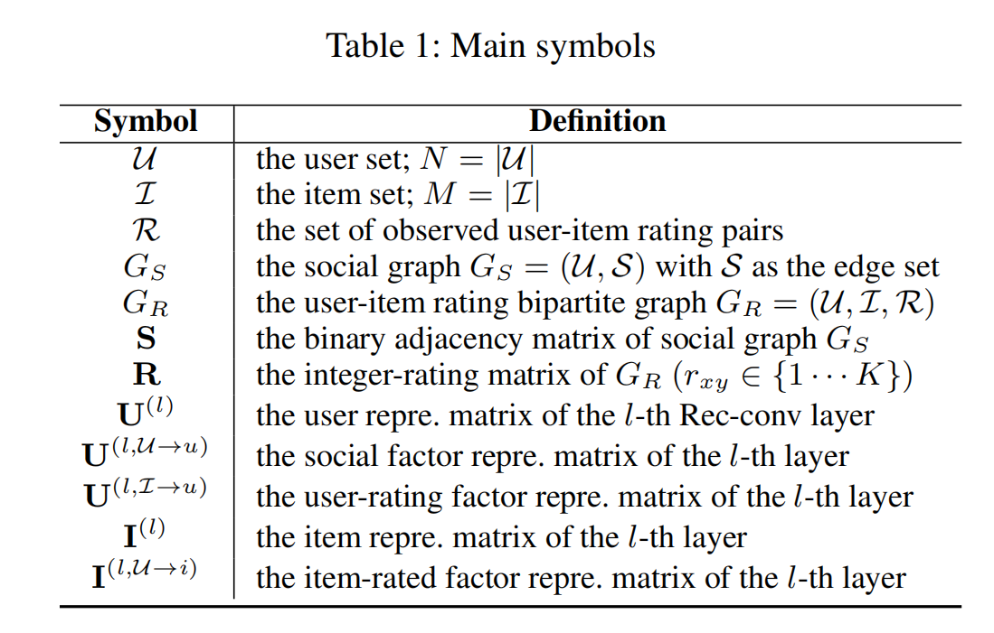

In this paper, we represent user/item set as U (N = |U|) and I (M = |I|), respectively. A social graph GS = (U, S) and a user-item rating bipartite graph GR = (U, I, R) are given. In GS, S describes users social connections. Let its adjacency matrix be S ∈ {0, 1}N×N with 1/0 representing if social relation exists between two users or not. In GR, R records the observed user-item rating pairs. Let R ∈ RN×M record user-item rating values. A user-item pair (x, y) ∈ R (x ∈ U, y ∈ I) is assigned with an existing integer rating value rxy ∈ R which ranges from 1 (“like least”) to K (“like most”). We also initialize the unobserved ratings in R with 0s. The goal of social recommendation is to estimate the unobserved ratings. Main notations of this paper are also summarized in Table 1.

: 用户的集合，

：项目的集合，

：观察到的user-item评分对集合

：作为社交图，其中为边的集合

：user-item评分图

：的二元邻接矩阵

**R** ：的整数的评分矩阵

: 第个循环卷积层的用户表示矩阵

: 第个循环卷积层的社交因子表示矩阵

：第个循环卷积层的用户评分因子表示矩阵

: 第个循环卷积层的项目表示矩阵

: 第个循环卷积层的项目评分因子表示矩阵

在本文中，我们将用户/项目集分别表示为和。 给出了社交图

和用户项评级二部图。 在中，描述了用户的社交关系。 令其邻接矩阵为，其中1/0表示两个用户之间是否存在社交关系。 在中，记录观察到的用户对项目的评分。 令记录用户项目的评分值。 用户-项对

被分配一个现有的整数额定值rxy∈R，其范围从1（“最小”）到K（“最大”）。 。 我们还将R中未观察到的等级初始化为0。 社会推荐的目的是估计未观察到的等级。 表1还总结了本文的主要符号。

**3.2 The Framework**

ASR targets to attentively fuse three factors (user-user social factor, user-rating factor, and item-rated factor) into user and item embedding. The overall architecture of ASR is shown in Figure 3(a).

ASR的目标是将三个因素（用户-用户社会因素，用户评价因素和项目评价因素）集中融合到用户和项目嵌入中。 ASR的总体架构如图3（a）所示**。**

We represent users and items with D-dimension latent vectors as U ∈ RN×D and I ∈ RM×D, respectively. User and item embedding vectors are updated by forwarding through stacked Rec-conv neural network layers.

我们用D维潜矢量分别将用户和项表示为和。 通过堆叠的Rec-conv神经网络层进行转发，可以更新用户和商品嵌入向量。

In each Rec-conv layer, the social factor features are extracted from the social graph GS; user-rating factor and item-rated factor features are obtained from the bipartite rating graph GR. In the meanwhile, the user and item embedding vectors are updated by attentively fusing all the three factors.

在每个Rec-conv图层中，从社交图GS中提取社交因素特征； 用户评价因子和项目评价因子特征可从二分评价图GR中获得。 同时，通过仔细融合所有三个因素来更新用户和项目嵌入向量。

After obtaining the final user/item embedding, we follow the common setting in the literature (Wu et al. 2019c; Fan et al. 2019b) to predict the unobserved rating value for a user x on an item y. We concatenate the user and item vectors and feed them into an MLP to predict the rating value r0 xy. During training, given the ground-truth rating rxy, we take the mean square error as the training objective:

在获得最终用户/项目嵌入之后，我们遵循文献中的通用设置（Wu等人2019c; Fan等人2019b）来预测用户x在项目y上的未观察到的评分值。 我们将用户和项目向量连接起来，并将其馈入MLP以预测评级值。 在训练过程中，给定地面真实等级，我们将均方差作为训练目标：

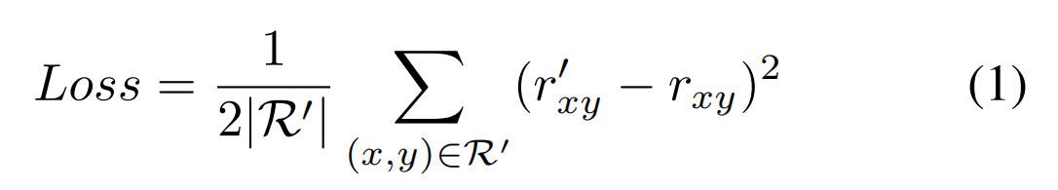

where ⊂ R is the training set containing observed ratings.

其中⊂ R是包含观察到的评分的训练集。

4 The Rec-conv Layer

In this section, we introduce our Rec-conv layer to attentively aggregate multiple factors from social and rating graphs in the user/item embedding. A diagram is shown in Figure 3(b). Two main processes in the Rec-conv layer are to update user embedding (Section 4.1) and item embedding Section 4.2.

在本节中，我们将介绍Rec-conv层，以便在用户/项目嵌入中集中汇总来自社交和评级图的多个因素。 图3（b）中示出了该图。 Rec-conv层中的两个主要过程是更新用户嵌入（第4.1节）和项目嵌入第4.2节。

4.1 Update User Embedding

Users are influenced by various factors, such as their own tastes (user-rating factor) and social effects from friends (social factor). To model these factors, in the l th Rec-conv layer, we use GNNs to generate two kinds of user latent vectors: user social vectors U(l,U→u) and user-rating vectors U(l,I→u) . An attention mechanism is used to attentively aggregate all factors. In the following, we take GCN (Kipf and Welling 2017) as an example. Note that Other GNNs can also be used, we evaluate their performance in Section 5.4.2.

用户受到各种因素的影响，例如他们自己的口味（用户评价因素）和来自朋友的社会影响（社会因素）。 为了对这些因素进行建模，在第l Rec-conv层中，我们使用GNN生成两种用户潜在向量：用户社交向量和用户评分向量 。 注意机制用于集中所有因素。 在下文中，我们以GCN（Kipf和Welling，2017年）为例。 注意，也可以使用其他GNN，我们将在5.4.2节中评估它们的性能。

**4.1.1 User Social Vector**

Social vectors are extracted by applying a GCN to propagate local neighbor’s information in the social graph. Formally

通过应用GCN在社交图中传播本地邻居的信息来提取社交矢量。 正式地

GCN标准形式化表述：

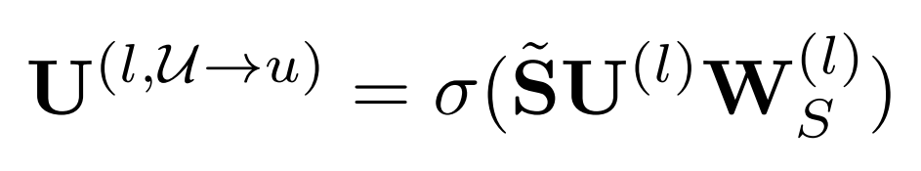

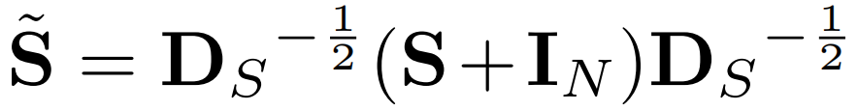是添加自链接的转化矩阵

第层的训练权重

*σ*(*·*) 代表激活函数

可以随机初始化或者用户配置文件矩阵

4.1.2 User-Rating Vector

The user-rating vector for a user reflects the user’s preference. And it is extracted from all the ratings in the bipartite rating graph. However, a GCN on the entire rating graph GR will mix distinct rating values which may represent opposite attitudes (e.g., value 1 and 5). So we apply a disentangling strategy to extract diverse rating effects. Note that we also verify the effectiveness of this disentangling strategy in Section 5.4.2.

用户的用户评分矢量反映了用户的偏好。 它是从二分评级图中的所有评级中提取的。 但是，整个评分图表上的GCN会混合不同的评分值，这些值可能代表相反的态度（例如值1和5）。 因此，我们采用一种解缠结的策略来提取各种评级效果。 请注意，我们还在5.4.2节中验证了这种解缠策略的有效性。

Specifically, we first induce rating subgraphs based on the K diverse rating values.

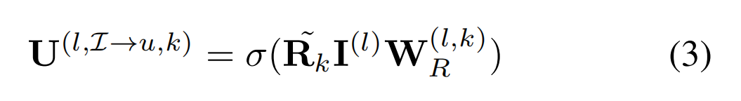

K channels of outputs encode different users rating attitudes. Finally, we concatenate them and project to D-dim. to obtain final user-rating vectors:

K个输出通道可对不同的用户评分态度进行编码。 最后，我们将它们连接起来并投影到D-dim。 获得最终的用户评级向量：

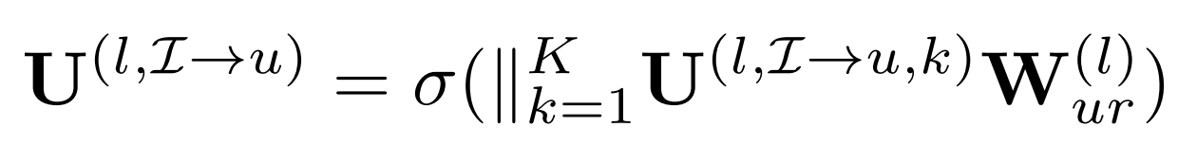

4.1.3 Attentive Aggregation For User Embedding

有三个因子需要考虑：

1. 前一层的用户嵌入向量
2. 社交因子
3. 用户评分因子

To differentiate impacts of these factors, we introduce attention mechanisms to control the information aggregated into the updated user embedding U(l+1) which is the input for the next Rec-conv layer. We let A(l,u) gate how much previous user embedding information to remember; A(l,U→u) and A(l,I→u) determine importance of the social factor and the user-rating factor.

为了区分这些因素的影响，我们引入注意力机制聚集到更新的用户嵌入中的信息，该信息是下一个Rec-conv层的输入。 我们让记录要记住多少先前的用户嵌入信息；

和确定社交因子和用户评分因子的重要性。

Without loss of generality, we take A(l,u) as an example. Calculation of A(l,U→u) and A(l,I→u) are similar.

在不失一般性的前提下，我们以为例。和的计算相似。



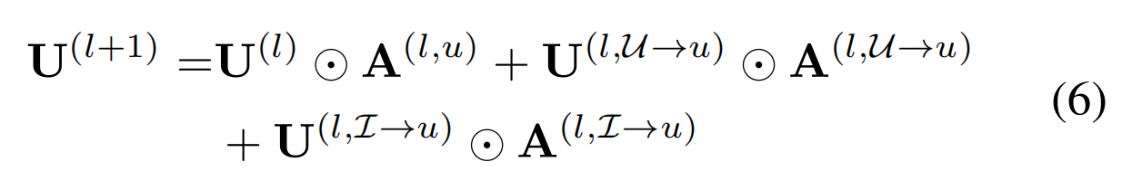

4.2 Update Item Embedding

To generate a latent vector for an item, not only its own previous item embedding but also the item-rated factor should be considered. We first generate item-rated vector, which encodes information from an item’s overall rating. Then the attention mechanism is introduced.

为了为项目生成潜在向量，不仅应考虑其自身先前的项目嵌入，而且还应考虑项目评级因子。 我们首先生成商品评级矢量，该矢量对商品总体评级中的信息进行编码。 然后介绍了注意机制。

**4.2.1 Item-Rated Vector**

The item-rated vector aggregates historical ratings of an item. Similar to the userrating factor in Section 4.1.2, we adopt K channels of GCN filters for diverse ratings. The output of the k th channel is

item-rated vector汇总了项目的历史评分。 类似于第4.1.2节中的用户评分因素，我们采用GCN卷积核的K通道进行各种评分。 第k个通道的输出为

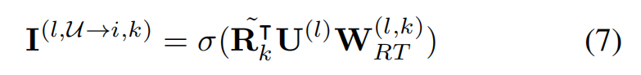

然后将得到的K个输出通过一层神经网络聚合为项目评分因子

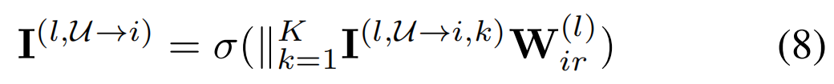

4.2.2 Attention Aggregation For Item Embedding

To update the item embedding vectors I(l+1), we introduce item attention mechanisms to assign contribution weights to the previous item vector I(l) and the item-rated vector I(l,U→i). Similar to the attention in user embedding updating, two item contribution matrices are:

为了更新项目嵌入向量，我们引入了项目注意机制，以将贡献权重分配给先前的项目向量和项目评级的向量。 与用户嵌入更新中的注意力机制类似，两个项目贡献矩阵为：

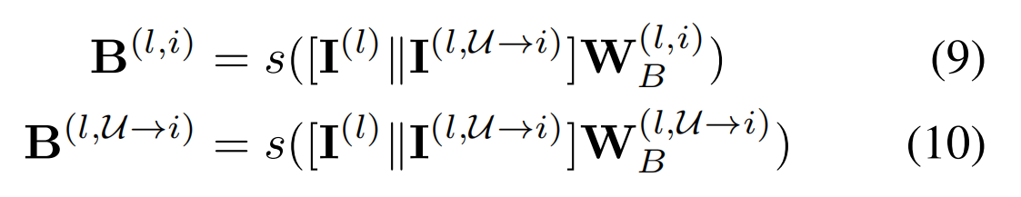Then we obtain the updated item embedding通过



然后我们获得更新的项目嵌入

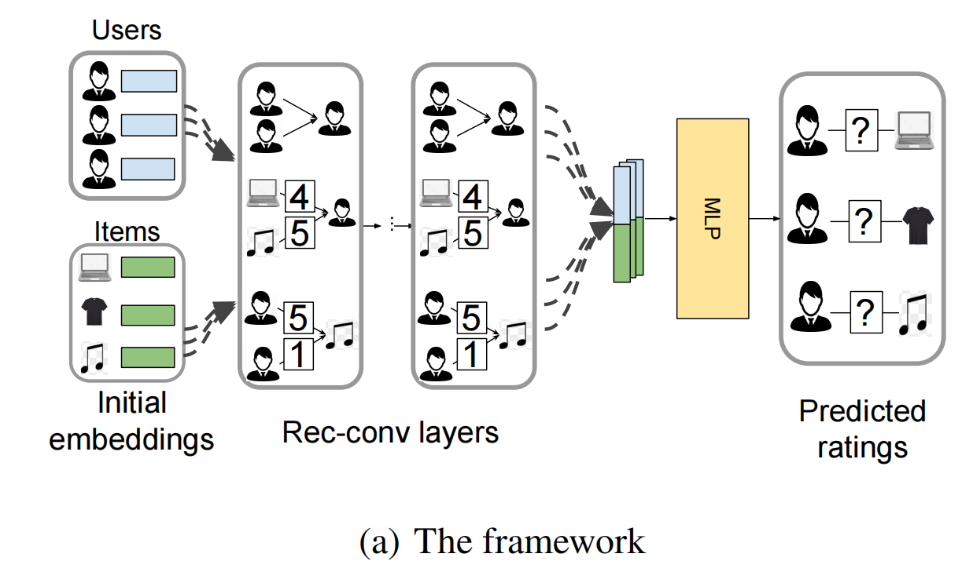

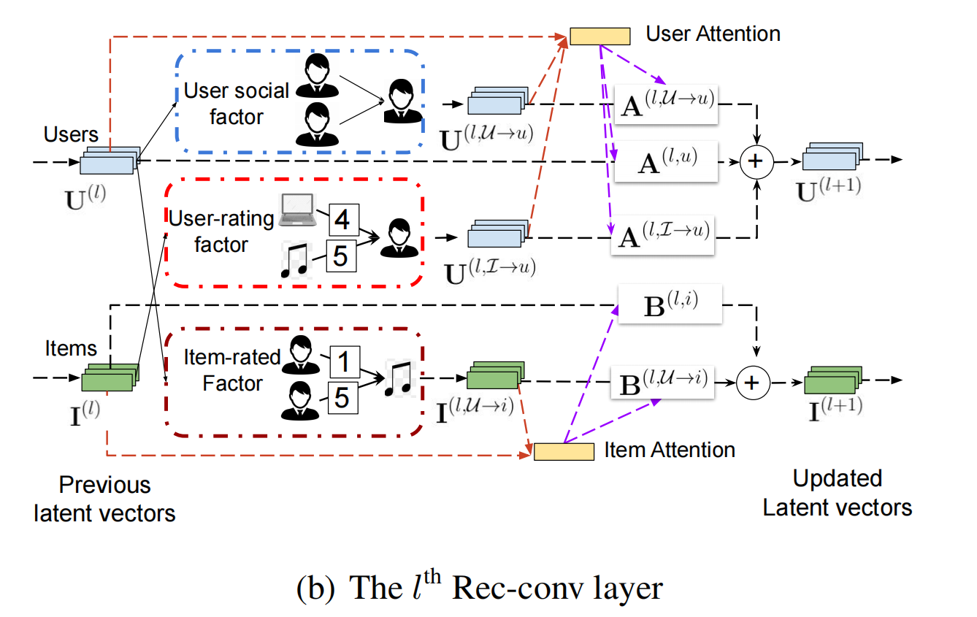

In summary, in each Rec-conv layer, using attention mechanisms, we dynamically aggregate social factor, userrating factor and item-rated factor into the user/item embedding vector.

总而言之，在每个Rec-conv层中，我们都使用注意力机制将社交因素，用户评价因素和项目评价因素动态汇总到用户/项目嵌入向量中。

We also emphasize that the attention mechanism help to alleviates the over-smoothing issue in GNN (Li, Han, and Wu 2018). Thus, stacked Rec-conv layers can effectively capture user/item diverse information. Related evaluations are provided in Section 5.4.3.

我们还强调指出，注意力机制有助于缓解GNN中的过度平滑问题（Li，Han和Wu 2018）。 因此，堆叠的Rec-conv层可以有效地捕获用户/项目的各种信息。 相关评估在第5.4.3节中提供。

**5 Experimental Study**

In this section, we perform extensive experiments to evaluate the performance of the proposed ASR method on two benchmarks, Ciao and Epinions. Social recommendation performances are shown in Section 5.2. Section 5.3 further checks the diversity of predicted ratings. Model evaluations and ablation studies for ASR are followed in Section 5.4. An effi- ciency evaluation is also provided in Section 5.5.

在本节中，我们将进行广泛的实验，以在Ciao和Epinions两个基准上评估所提出的ASR方法的性能。 社会推荐表现见5.2节。 第5.3节进一步检查了预测评分的多样性。 5.4节中进行了ASR的模型评估和消融研究。 5.5节还提供了效率评估。

5.1 Experimental Settings

5.1.1 Datasets And Baselines

Two benchmark datasets Ciao and Epinions1 are used. In these datasets, users can rate and give comments on items. The rating values are integers from 1 (like least) to 5 (like most). Besides, they can also select other users as their trusters. We use the trust graphs as social graphs. The statistics are summarized in Table 2.

使用了两个基准数据集Ciao和Epinions1。 在这些数据集中，用户可以对项目进行评分并提供评论。 评级值是从1（最小）到5（最大）的整数。 此外，他们还可以选择其他用户作为其信任者。 我们将信任图用作社交图。 表2汇总了这些统计信息。

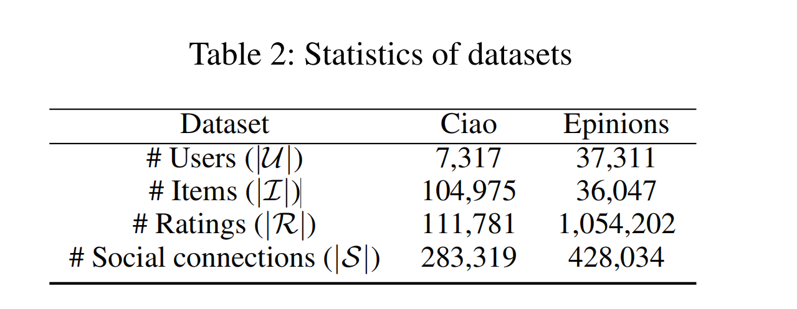

We compare ASR with state-of-the-art baselines with publicly available codes, including a traditional recommendation method (UserMean, ItemMean, and SVD++), social recommendation methods (SocialReg and RSTE), and deep learning-based models (GraphRec, DANSER). UserMean and ItemMean predict an unobserved rating with the average of the user’s and item’s rating values, respectively. SVD++ (Koren 2010) is a collaborative filtering method considering both explicit and implicit feedback. SocialReg (Ma et al. 2011) treats the social graph as regularization and use a matrix factorization framework. RSTE (Ma, King, and Lyu 2009) models users’ favors and their friends’ tastes with a probabilistic factor framework. GraphRec (Fan et al. 2019b) uses attention mechanisms to learn user/item embedding separately from social graph and user-item graph. DANSER (Wu et al. 2019c) captures user/item dynamic/static features by GATs.

我们将ASR与具有公开代码的最新基线进行比较，这些代码包括传统的推荐方法（UserMean，ItemMean和SVD ++），社交推荐方法（SocialReg和RSTE）以及基于深度学习的模型（GraphRec，DANSER） ）。 UserMean和ItemMean分别使用用户和项目的评分值的平均值预测未观察到的评分。

SVD ++（Koren，2010年）是一种同时考虑显式和隐式反馈的协作过滤方法。

SocialReg（Ma et al。2011）将社交图视为正则化并使用矩阵分解框架。

RSTE（Ma，King和Lyu，2009年）使用概率因子框架来模拟用户的偏爱和他们的朋友的品味。

GraphRec（Fan et al.2019b）使用注意力机制来独立于社交图和用户项目图来学习用户/项目嵌入。

DANSER（Wu et al.2019c）通过GAT捕获用户/项目的动态/静态功能。

Note that we do not involve and compare with methods for top-N recommendation, such as DiffNet (Wu et al. 2019a, 2020). Because top-N recommendation targets to retrieve or rank N items for users even utilizing temporal information instead of directly predicting user-item rating values. And the latter is our main purpose of social recommendation in this paper.

请注意，我们没有涉及和比较top-N推荐方法，例如DiffNet（Wu et al.2019a，2020）。 因为top-N推荐的目标是用户甚至利用时间信息，而不是直接预测用户项目的评级值。也可以为用户检索或排序N个项目。 后者是本文社会推荐的主要目的。

5.1.2 Parameter Settings

For each dataset, we randomly split 80% existing user-item ratings as the training set, 10% as the validation set for tuning hyperparameters, and the left 10% for testing. For ASR, we set the embedding dimension to 16, the batch size to 4096 and the learning rate to 0.0003. We stack two Rec-conv layers (with GCN architecture2 and ReLU activation function) followed by an MLP for prediction. Early stopping is also used. For other methods, we follow instructions in their papers to carefully tune hyperparameters, including but not limited to embedding size, batch size and learning rate, and report their best results.

对于每个数据集，我们随机将80％的现有用户项目评分作为训练集，将10％作为用于调整超参数的验证集，将剩余的10％用于测试。 对于ASR，我们将嵌入尺寸设置为16，批量大小设置为4096，学习率设置为0.0003。 我们堆叠两个Rec-conv层（具有GCN体系结构2和ReLU激活功能），然后堆叠一个MLP进行预测。 还使用提前停止。 对于其他方法，我们按照其论文中的说明仔细调整超参数，包括但不限于嵌入大小，批处理大小和学习率，并报告其最佳结果。

5.2 Performance Comparison

We adopt two widely used metrics, mean absolute error (MAE) and root mean square error (RMSE) (Wu et al. 2019c). Smaller MAE and RMSE scores indicate better performance. We repeat each experiment 5 times and report average results on testing set in Table 3 (first two columns of each dataset). The best performer is highlighted with bold fonts. Note that small improvements in MAE or RMSE will lead to significant enhancement on the performance of the top-N recommendation (Fan et al. 2019b). From the table, we observe:

我们采用两种广泛使用的度量标准，即平均绝对误差（MAE）和均方根误差（RMSE）（Wu等人2019c）。 MAE和RMSE分数越小，表示性能越好。 我们将每个实验重复5次，并在表3（每个数据集的前两列）中报告测试集的平均结果。 效果最佳的字体以粗体突出显示。 请注意，MAE或RMSE的小幅改进将显着提高top-N建议的性能（Fan等人2019b）。 从表中，我们观察到：

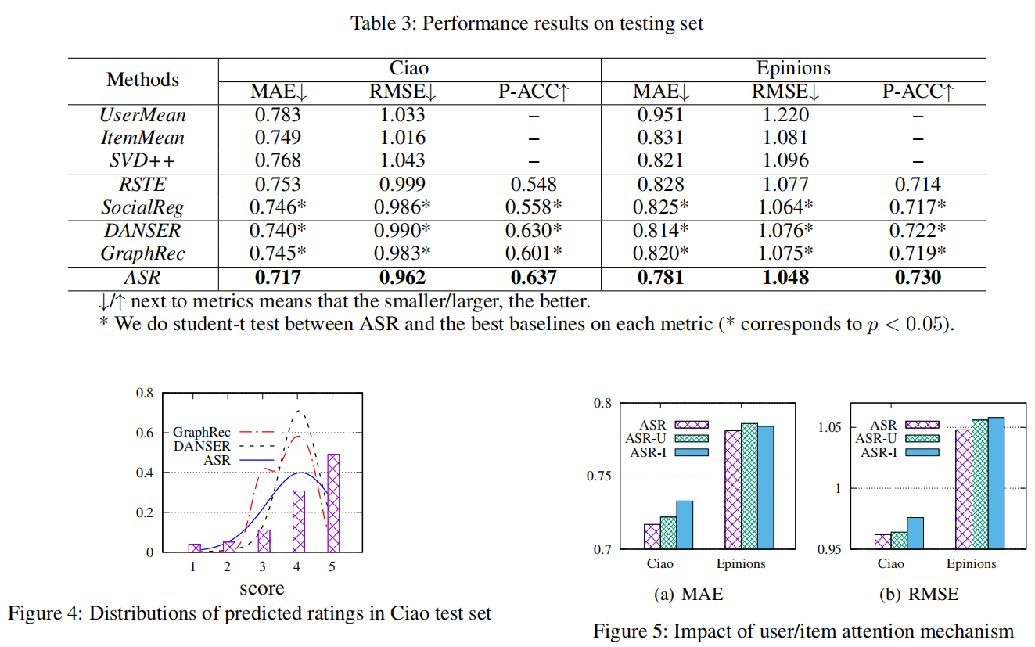

Among the matrix factorization-based methods (SVD++, SocialReg, and RSTE), SVD++ only utilizes user-item rating information, while the two better performers, SocialReg and RSTE, use the social graph as additional information. Comparing them verifies that social factor can provide complementary information for recommendations

在基于矩阵分解的方法（SVD ++，SocialReg和RSTE）中，SVD ++仅利用用户项评级信息，而性能更好的两个社会主义者SocialReg和RSTE使用社会图作为附加信息。 比较它们可以验证社会因素可以为建议提供补充信息

Interestingly, we observe that in some cases, the simple method ItemMean outperforms SVD++ in Ciao and Epinions (RMSE). This observation is similar as that pointed out by Dacrema, Cremonesi, and Jannach (2019). They also found that simple methods may achieve comparable performances with more complicated alternatives.

有趣的是，我们观察到在某些情况下，简单方法ItemMean在Ciao和Epinions（RMSE）中的性能优于SVD ++。 这种观察与Dacrema，Cremonesi和Jannach（2019）指出的相似。 他们还发现，简单的方法可以使用更复杂的替代方法达到可比的性能。

In general, GNN-based methods, including ASR, GraphRec, and DANSER, outperform traditional social recommendation baselines. Because GNN models can more effectively aggregate information from both social and rating graphs. The comparison between these two types of methods reflects the power of GNN for social recommendation systems.

通常，基于ANN，GraphRec和DANSER的基于GNN的方法要优于传统的社会推荐基准。 因为GNN模型可以更有效地汇总来自社交图和评级图的信息。 两种方法之间的比较反映了GNN在社会推荐系统中的作用。

ASR outperforms others in both datasets with statistical significance. This is because ASR considers the diversity of users and items and combine multiple diverse factors. In ASR, attention mechanisms can actively extract and aggregate the social, user-rating and item-rated factors from the social and rating graph. The disentangling strategy also differentiates impacts of different rating values. Detailed evaluations are shown in Section 5.4.

在两个数据集中，ASR的性能均优于其他数据集。 这是因为ASR考虑了用户和项目的多样性，并结合了多种多样的因素。 在ASR中，注意力机制可以从社交和评分图中主动提取和汇总社交，用户评分和项目评分因素。分离策略还可以区分不同评级值的影响。 详细评估请参见第5.4节。

5.3 Diversity of User-Item Ratings

Except for ASR’s better results on MAE and RMSE, in this section, we demonstrate that ASR can obtain more accurate and diverse ratings than baselines.

除了ASR在MAE和RMSE上的更好结果外，在本部分中，我们证明ASR可以获得比基准更准确，更多样化的评级。

Because MAE and RMSE are both for the overall performance, we now check whether a model can predict accurate ratings for each user with the pairwise-ranking accuracy (P-ACC). Suppose that one user has distinct ratings for two items, we define a hit when one algorithm can predict the ratings with the correct relative ranking. Then P-ACC reflects the overall hitting rate. Higher P-ACC means better performance. Table 3 (the third column of each dataset) shows the P-ACC results over the testing set. Note that we only consider the top-5 performers. Results evidence that ASR can predict more accurate individual rating-rank.

由于MAE和RMSE都针对整体性能，因此我们现在检查模型是否可以通过成对排名准确性（P-ACC）预测每个用户的准确评分。 假设一个用户对两个项目具有不同的评分，则当一种算法可以预测具有正确相对排名的评分时，我们定义一个匹配。 然后，P-ACC反映总体命中率。 更高的P-ACC意味着更好的性能。 表3（每个数据集的第三列）显示了测试集中的P-ACC结果。 请注意，我们只考虑前五名的表现。 结果证明，ASR可以预测更准确的个人评分等级。

Next, we check the goodness of overall rating distributions of ASR and the other two best baselines DANSER and GraphRec. The bars in Figure 4 are the ground-truth rating histogram of Ciao testing set. We can see that GraphRec predicts most ratings as “3” and “4” and neglects other values even for the most value “5” in the ground-truth. DANSER even narrows its all ratings around “4” (values in [3.6, 4.3] covers more than 80% of its ratings). However, ASR can fit better with the ground-truth by considering the rating diversity.

接下来，我们检查ASR和其他两个最佳基准DANSER和GraphRec的总体评级分布是否良好。 图4中的条形图是Ciao测试集的地面真实等级直方图。 我们可以看到，GraphRec预测大多数评级为“ 3”和“ 4”，而忽略了其他值，即使对于真实情况中的最大值“ 5”也是如此。 DANSER甚至将其所有评分缩小到“ 4”左右（[3.6、4.3]中的值覆盖了其评分的80％以上）。 但是，通过考虑等级差异，ASR可以更好地适合实际情况。

5.4 Model Analysis

In this section, we conduct ablation study for ASR. Three aspects are evaluated: the necessity of the two main components of ASR, i.e., inter-factor attention mechanisms and the disentangling strategy; and the sensitivity of ASR to oversmoothing of GNNs (Li, Han, and Wu 2018).

在本节中，我们将对ASR进行消融研究。 从三个方面进行了评估：ASR的两个主要组成部分的必要性，即要素间注意机制和解散策略； 以及ASR对GNN过度平滑的敏感性（Li，Han和Wu 2018）。

5.4.1 Impact of Inter-Factor Attention Mechanisms

5.4.1因素间注意力机制的影响

To capture inter-factor contribution, we apply attentions in user/item embedding updating. To show the effectiveness of the attention, we compare ASR with two variants:

为了捕获因素间的影响，我们在用户/项目嵌入更新中给予了关注。 为了显示注意力的有效性，我们将ASR与两个变体进行了比较：

MAE and RMSE results of ASR and its two variants are shown in Figure 5. We can see that ASR achieves the best MAE and RMSE scores in both Ciao and Epinions. Comparing ASR with ASR-U and ASR-I, we conclude that including user/item inter-factor attentions provides ASR powerful and flexible abilities to effectively aggregate impacts from multiple factors, which leads to better results.

ASR及其两个变体的MAE和RMSE结果如图5所示。我们可以看到，ASR在Ciao和Epinions中均获得了最佳的MAE和RMSE分数。 将ASR与ASR-U和ASR-I进行比较，我们得出的结论是，包括用户/项目内部因素注意在内，ASR具有强大而灵活的功能，可以有效地汇总多种因素的影响，从而带来更好的结果。

DisDGC：在ASR中移除注意力机制

DCG：在ASR中移除注意力机制和分离策略

在本文中，我们提出了一种细心的社会推荐方法ASR。 ASR包括用户和项目注意，以捕获用户和项目的多样性。 所提出的Recconv网络层和注意力机制使ASR能够从用户社交图和用户项评级图中主动提取和融合社交因素，用户评级因素和项目评级因素。 此外，还开发了一种解缠策略，以汇总用户项评分图中来自不同评分的信息。 在两个基准数据集上的综合实验证明了ASR的有效性。 对注意力机制，解缠策略和GNN的消融研究证明了这些模块的必要性。 我们可以在ASR中堆叠多个Rec-conv图层，但较少受到过度平滑的影响。 ASR的培训过程也比其他方法快得多。